- Cash (register)
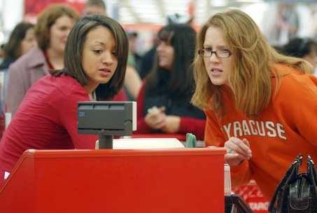
Customer service is not a department, it’s an attitude

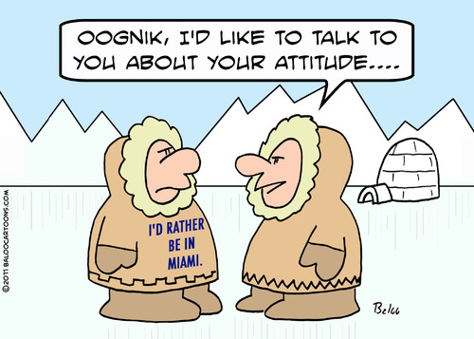
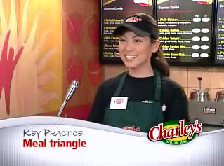
- Watch the film
Cashier training
Answer next questions.(Dutch)
- The instructor says: ”You do not get a second chance for
a first impression.” What does she mean with that?
- What is a ‘smile’ according to her?
- Why is having fun so important?
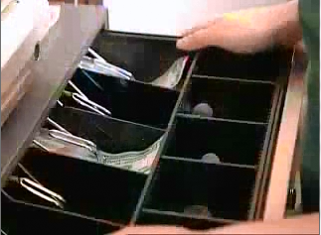
- Greeting must be individual, how do you do that?
- What means: ‘provide correct change’?
- What can you do with a frequency card?
- How long may a complete transaction last?
- What is the food triangle?
- When does the customer get a sandwich for free?
- What must you do with the bill you receive from a customer?

- Instructions: How to Tie a Wreath Bow

- Cash register information

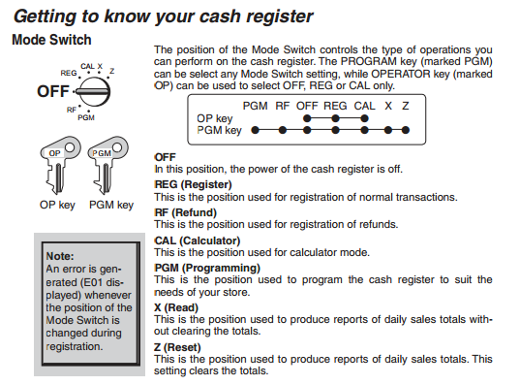

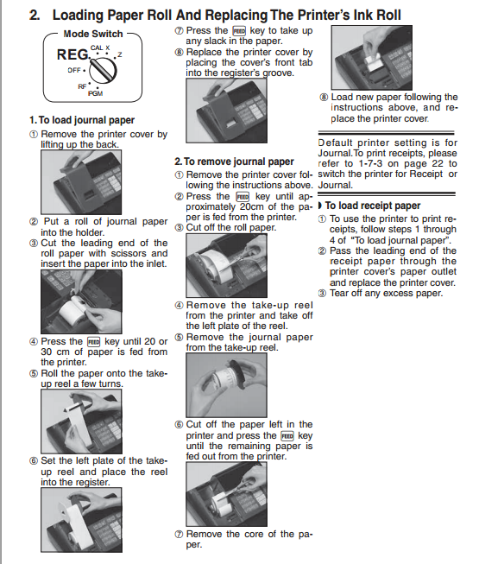
Answer the next questions.(Dutch)
1. There are two different keys, which ones, and why?
2. At what position you can produce reports?
3. When do you get the erro message E01?
4. How can you clear the totals of the day?
5. In what position must be the key to replace the paper roll?
6. Is it a two or one reel system?
7. How long must be the leading end of the paper?
8. The default settings are for printing journal not receipts; what does that mean?
9. What is the FEED key for?
10 What is meant by: ‘tear off any excess paper’
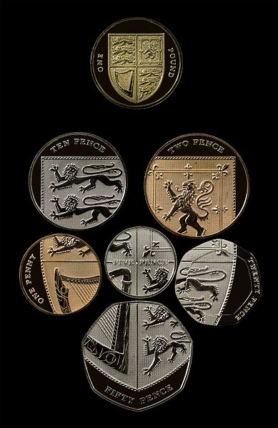
3. The pound sterling (GBP)
All frequently used coins except the £2 coin (coins shown are those after the extensive 2008 redesign).
Penny – pence
Pound - pounds

1 EUR = 0.8 GBP

Coin – coins

Pence (p) | Pounds (£)
1p | £ 1
2p | £ 2
10 p
20p
50p

Banknotes
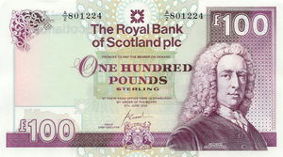 | 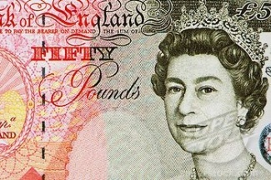 | 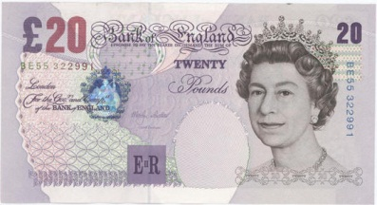
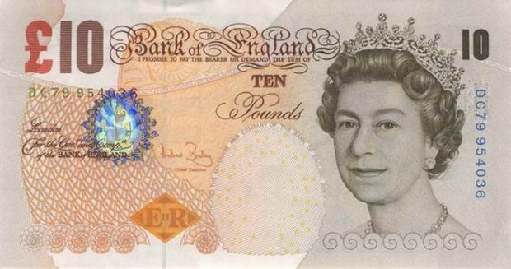 | 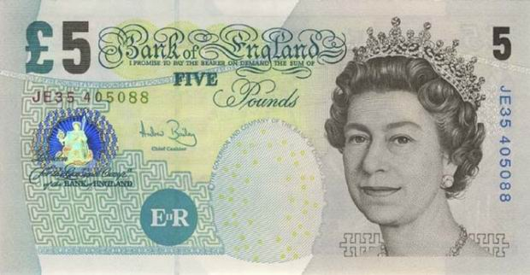

Fill out next form/table.
Return and change
Cost - price | Payd with | Change | ±Value in euro’s
£ 3.75 | £ 5 | £ 1 + 20p+2p+2p+1p | € 4,31
£ 88 | £ 50+£ 50
£ 34 | £ 20+£ 20
£ 26.50 | £ 20+£ 10
£ 1.95 | £ 2
£ 0.65 | £ 1
£ 55 | £ 50+£ 20
£ 73.40 | £ 50+£ 50
£ 0.25 | 50p
£ 6.85 | £ 10

- Make a presentation
Prepare a presentation for next class. You can use whatever media you want. For example you might use PowerPoint for a slide show and give your comment. The subject must be something of your education.
Please pay attention to next issues:
Target group (who is your audience?) Objectives (what do you want to achieve?) Subject (What is it all about?). Brood over the beginning and the ending of your presentation.

